**CUSTOMER CARE**

**REGISTRY**

**BRAINSTORM & IDEA**

**PRIORITIZATION**

**TEAM DETAILS**

Team No : PNT2022TMID41

PROJECT NAME : CUSTOMER CARE REGISTRY

**TEAM MEMBERS**

**BRAINSTORM & IDEA PRIORITIZATION**

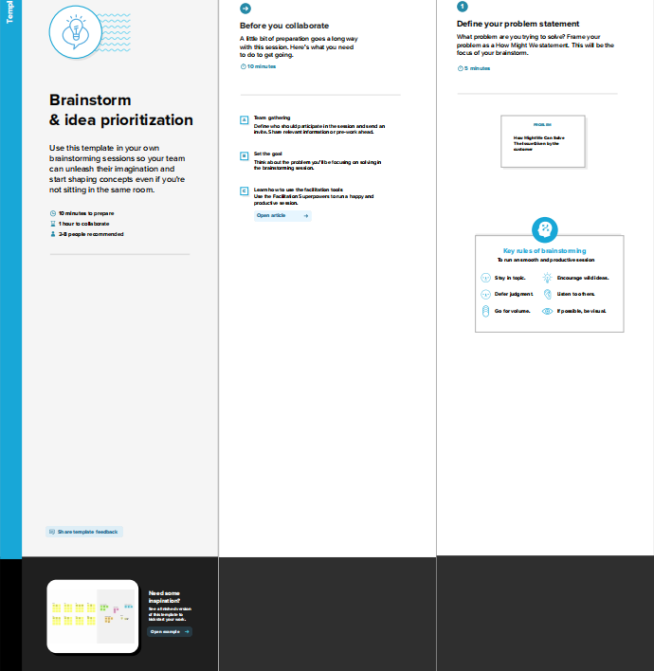

**BRAINSTORM & IDEA PRIORITIZATION**

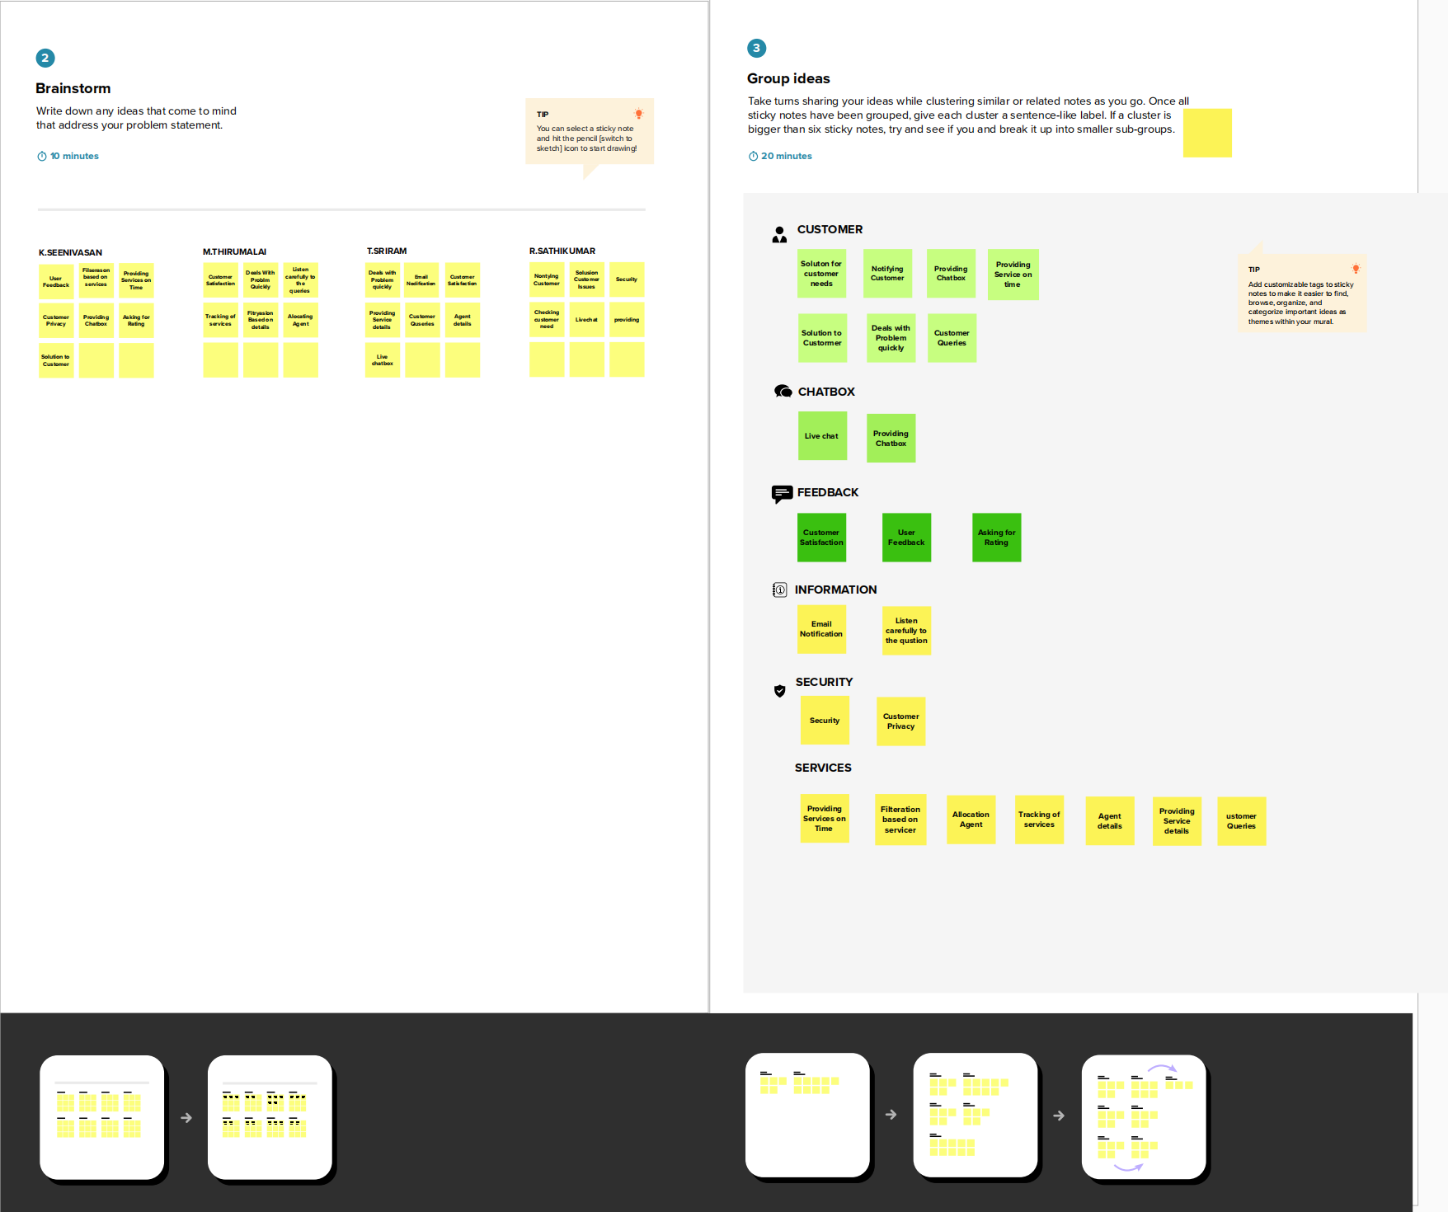

**BRAINSTORM & IDEA PRIORITIZATION**

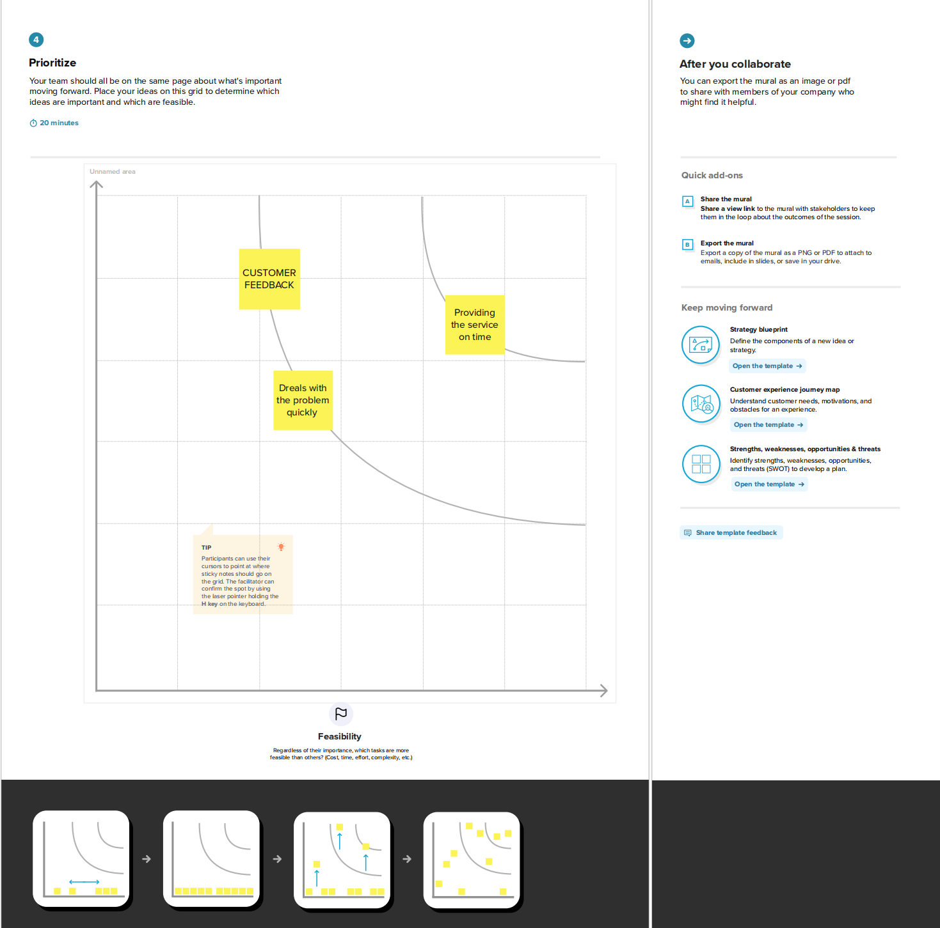

***Thank you***